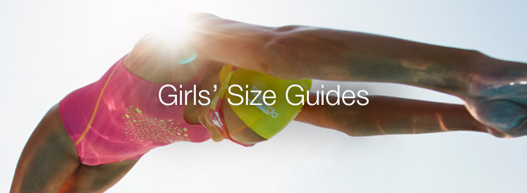

Size Speedo Girl

Our girls' swimwear sizing is based on chest measurement, and we have also included an appropriate age range, to make it easier to find the right size for your child.
Speedo Size | Chest  (in / cm) | Height  (cm) | Age  (years) | DE | FR | IT | AU
24 | 24" / 60cm | 116 | 5 - 6 | 116 | 6 | 6 | -
26 | 26" / 65cm | 128 | 7 - 8 | 128 | 8 | 8 | GIRL 6
28 | 28" / 70cm | 140 | 9 - 10 | 140 | 10 | 10 | GIRL 8
30 | 30" / 75cm | 152 | 11 - 12 | 152 | 12 | 12 | GIRL 10
32 | 32" / 80cm | 164 | 13 - 14 | 164 | 14 | 14 | GIRL 12
34 | 34" / 85cm | 176 | 15 - 16 | 176 | 16 | 16 | GIRL 14

